**Requirement 1:**

**/home/test/Desktop/sprint2/riskXSS.py**

Vulnerable as `\` is a simple restriction which can be avoided using `img` or other techniques and weak code sanitisation uses replace, better methods such as whitelisting are more secure. This can lead to being vulnerable to XSS (cross site scripting). A simple fix could be to use whitelisting based input validation and sanitise server side inputs to prevent injection

YAML file and file to be scanned

Corrected code without the error and semgrep scan

**/home/test/Desktop/sprint2/RiskDos.py**

Vulnerable as an inefficient sort algorithm is used -- attackers can send a large array of elements causing algorithm to take too long to complete resulting in DoS attack. Simple fix is using a more efficient sort algorithm

YAML file and file to be scanned

Corrected code with semgrep scan

**/home/test/Desktop/sprint2/riskLeak.c**

The code is vulnerable to a memory leak because if fopen fails the memory isn’t freed before the program exits which leads to a memory leak. A simple fix to this is adding free(buffer) if fopen potentially fails.

YAML file and file to be scanned

Corrected code with semgrep scan

**Requirement 2**

I installed docker and pulled a container for this requirement

**Sudo docker pull ollama/ollama**

**sha256:722ce8caba5f8b8bd2ee654b2e29466415be3071a704e3f4db1702b83c885f76**

**syft ollama/ollama -o cyclonedx-json > ollama_sbom.cyclonedx.json**

**jq . ollama_sbom.cyclonedx.json**

Dependency track SBOM uploaded vulnerabilities in browser at localhost:8080

Command for grype is **grype ollama_sbom.cyclonedx.json** which created the txt file you can see in the screenshot below

**Requirement 3:**

I installed clang and libfuzzer

This is my vulnerable code I will run commands on

**gcc -Wall -Wextra -Wpedantic -o buffer buffer.c**

**clang -fsanitize=address -g -o buffer buffer.c**

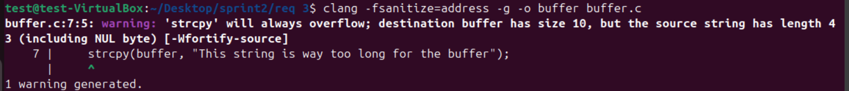

After running **./buffer** this was the whole output

This is the updated and fixed c file

After fixing the code and rerunning these commands this is my output

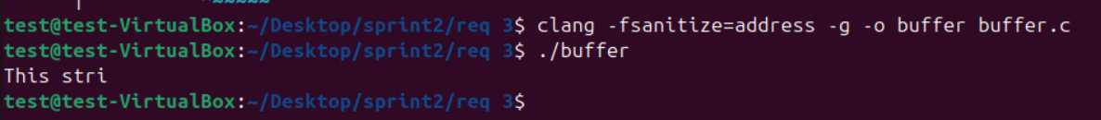

The commands I used were

**clang -fsanitize=fuzzer -g fuzzTarget.c -o fuzz_target**

**./fuzz_target -runs=1**

I originally just used **./fuzz_target** but it would give me the infinite output of ‘Crash!’ so I made it only fuzz the target once to give me a proper output

The sanitizer was able to pick up on the crash because it detected the undefined behaviour like dividing by 0 during the runtime

For the next task I used 3 different files

This file is my fuzz_target.c, this file is the fuzzing harness for libfuzzer to catch the bugs

This file is my target_file.c, this file contains the implementation of the functions Im testing for

This file is my target_file.h, this file contains the declatrations of the functions from target_file.c to be used in the fuzzing harness

The commands I used to get the result you see below are

**clang -fsanitize=fuzzer,address,undefined -g target_file.c fuzz_target.c -o fuzz_target**

**./fuzz_target -runs=1**

